

DECKON PREMIUM METAL CEILINGS
PANEL C SYSTEM
DATASHEET

Technical Info:

Product : aluminium or galvanised steel
Module : 75-150-300 C
Thickness : 0.50 - 0.70 mm
Surface : electrostatic powder coated
Perforation : none or ∅1.8-2.5mm hole diameter
Suspension sys : main carrier profile
Fire Resistance : class A as steel
Color : RAL 9016 - standard white or desired RAL colors

Specification:
The Linear Closed Ceiling SystemClosed aluminium ceiling panels with bevelled edges, when installed creates closed smooth appearanceCombination of 3 widths 75/150/300 mm. All three widths can be clipped to an integrated main carrierPanels can be supplied in any length up to 6000 mm. Mostly available as aluminium. This system is suitable for all wide range of building sectors including Corporate, Transport (airports, metro, bus & train stations) Retail, Leisure, Public space, Hospitality, Healthcare, Education and Residential.
VISUAL
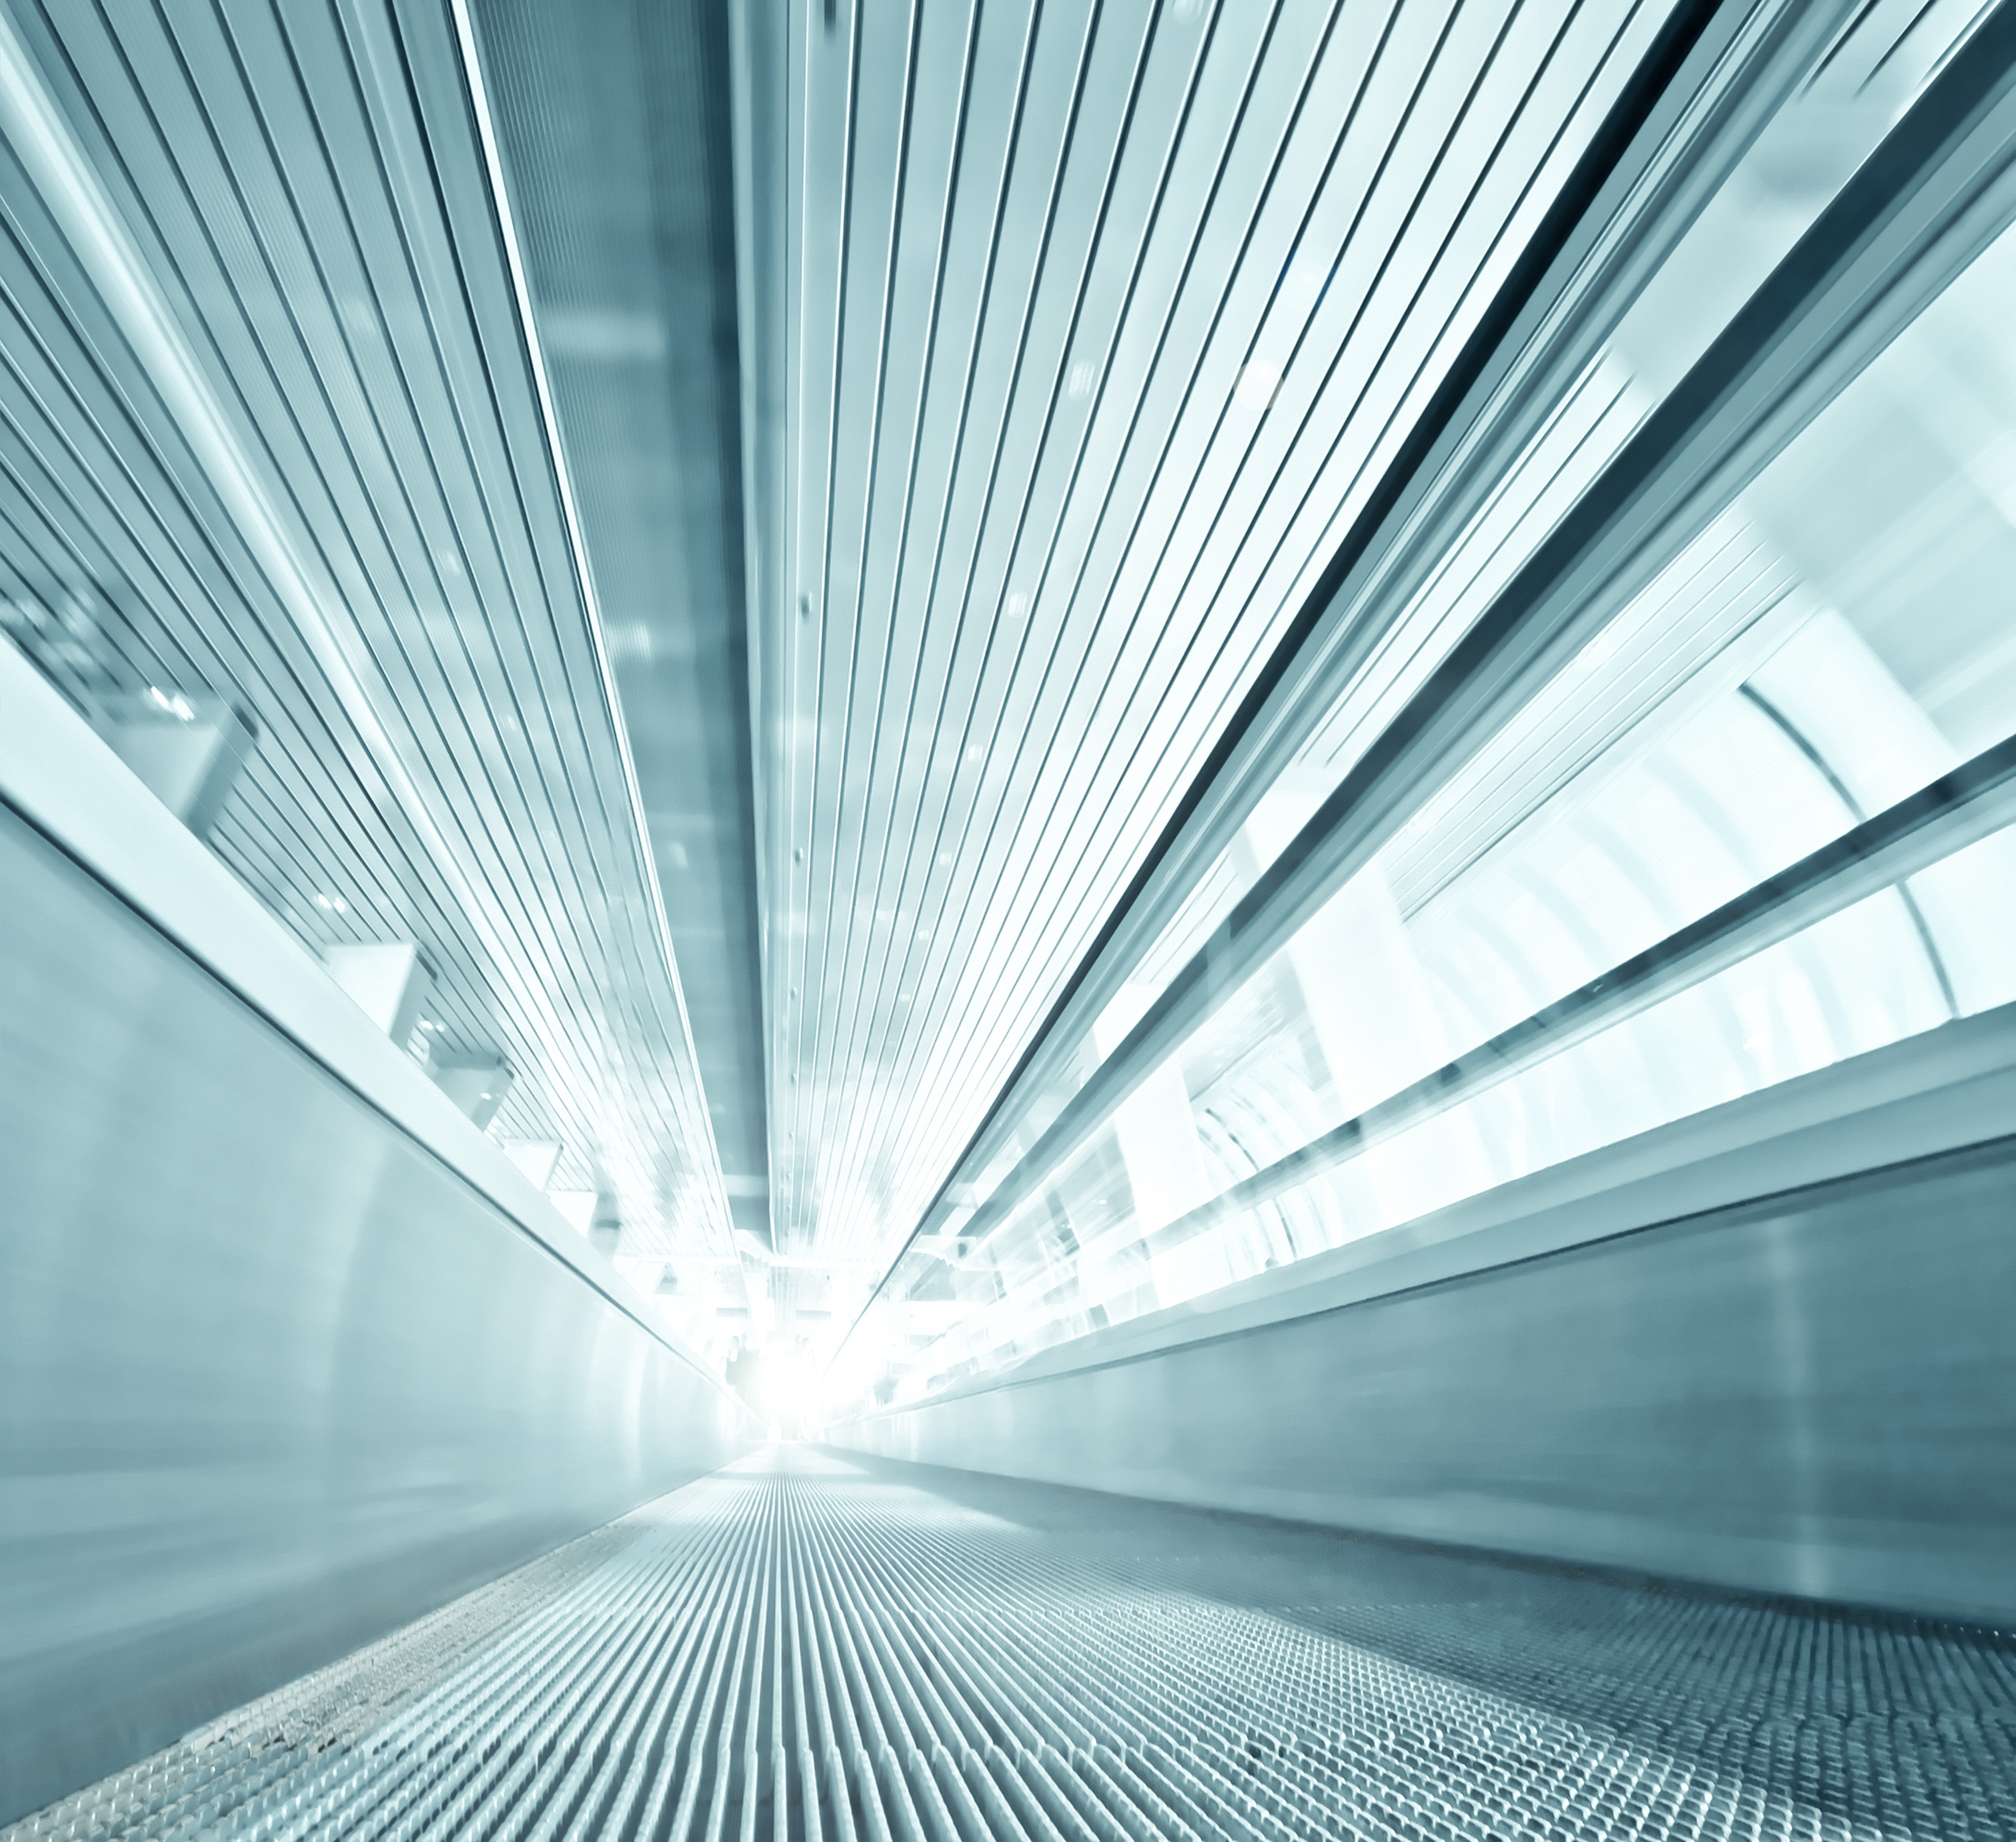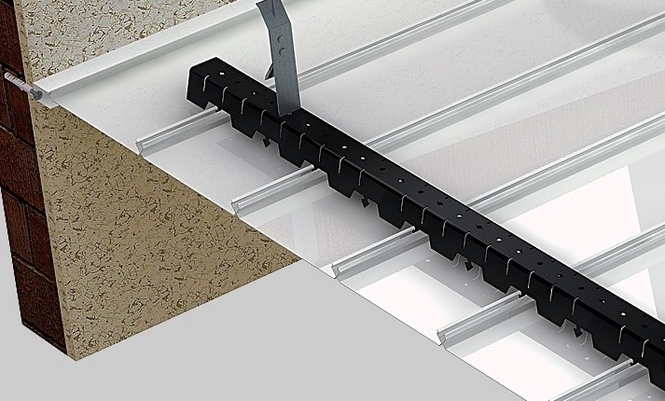
TECHNICAL DRAWING 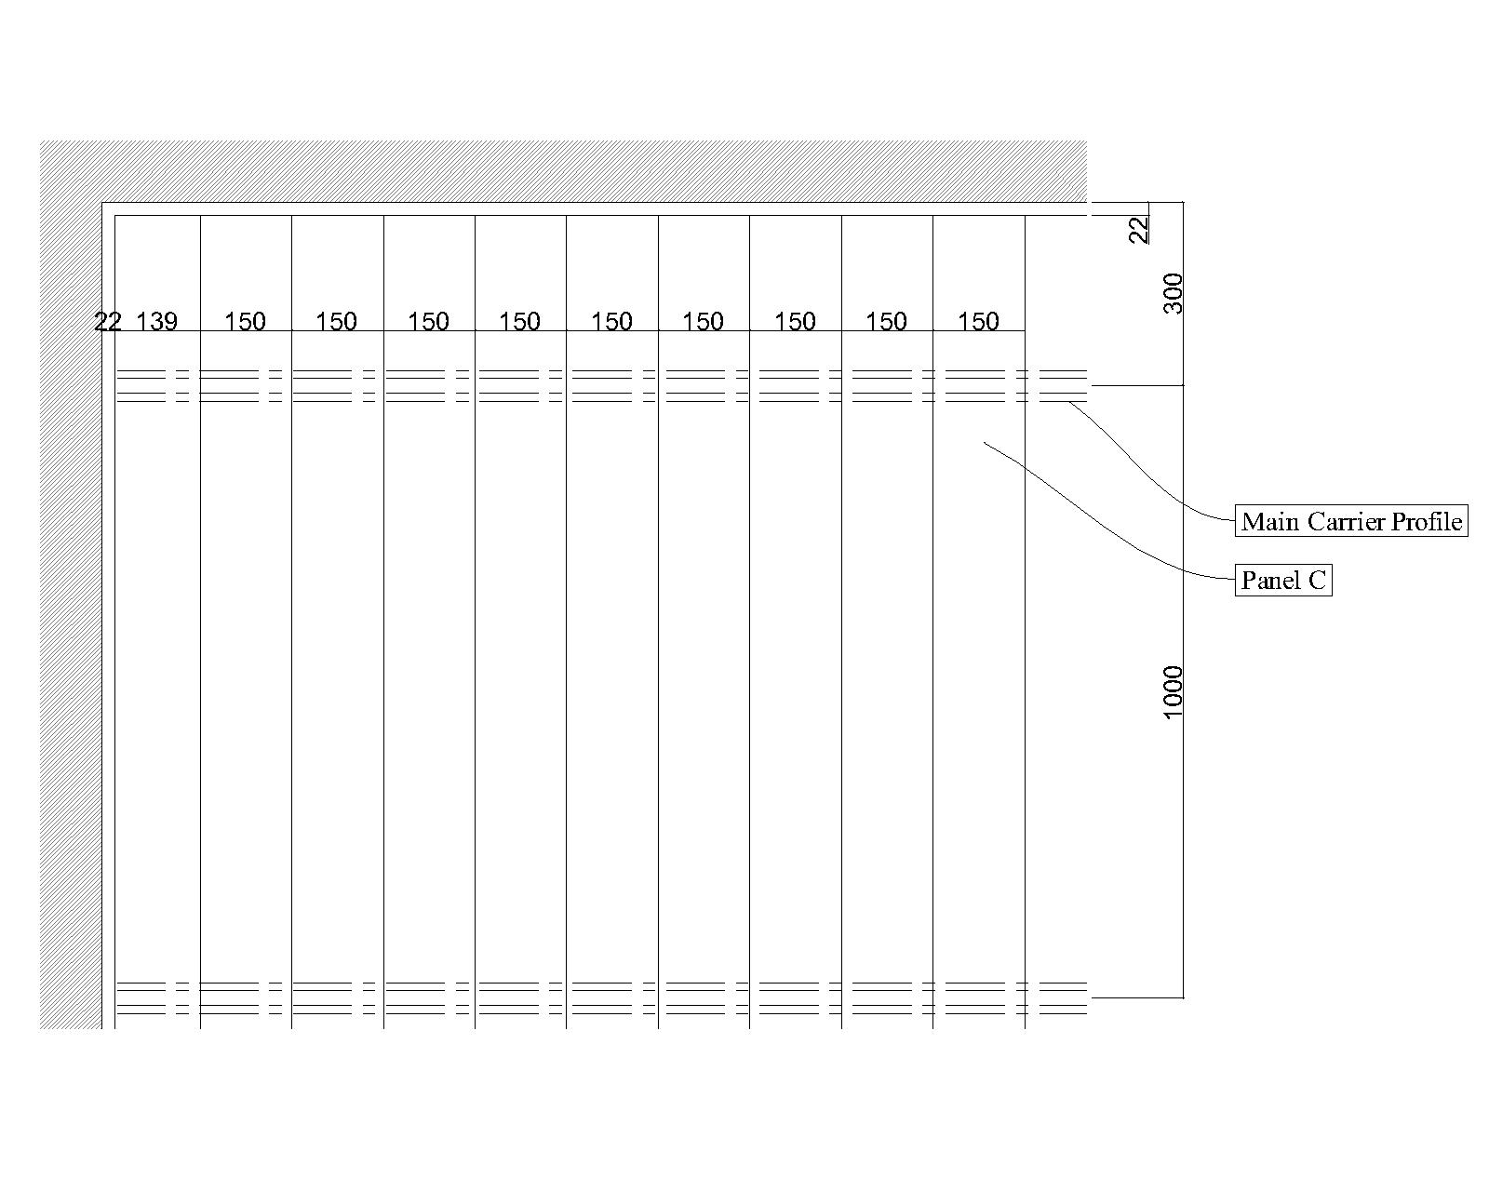
PLAN
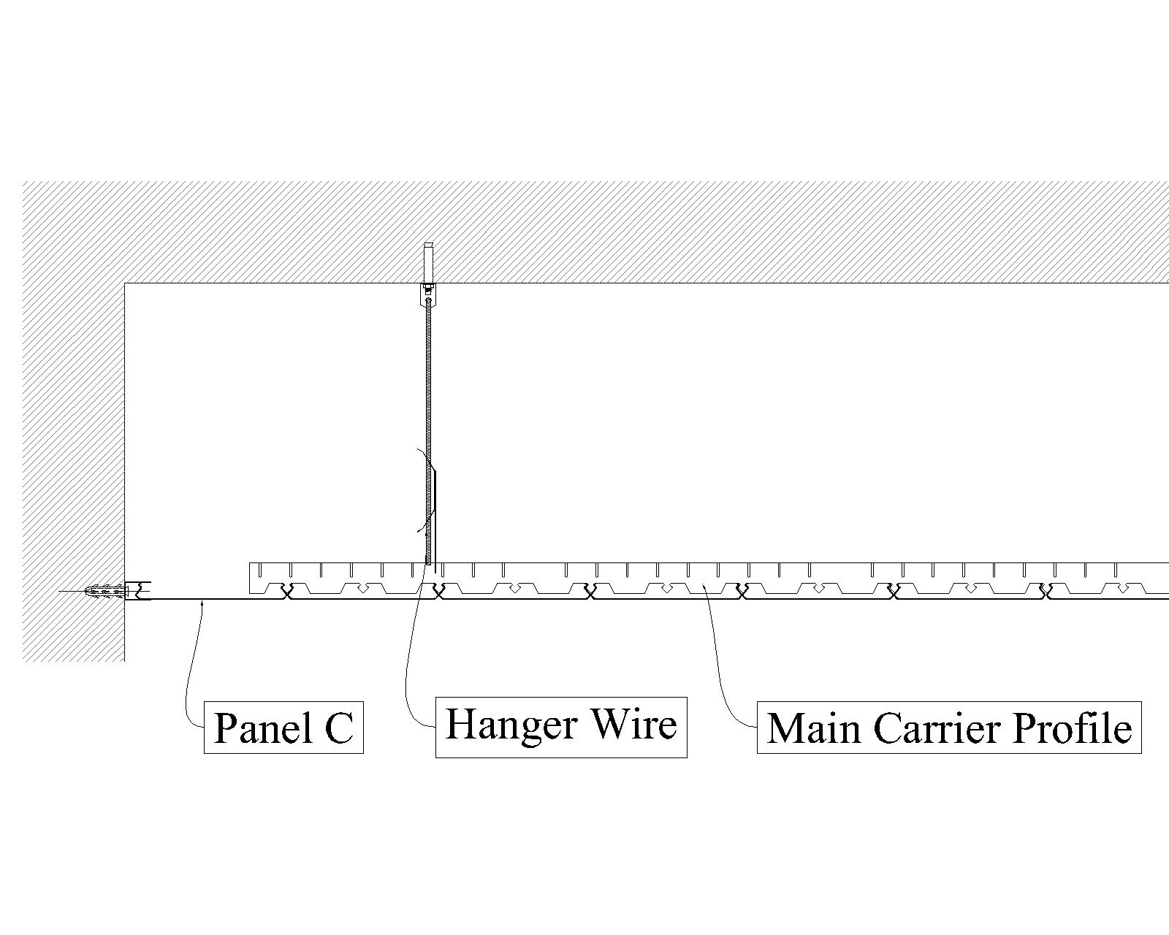
SECTION
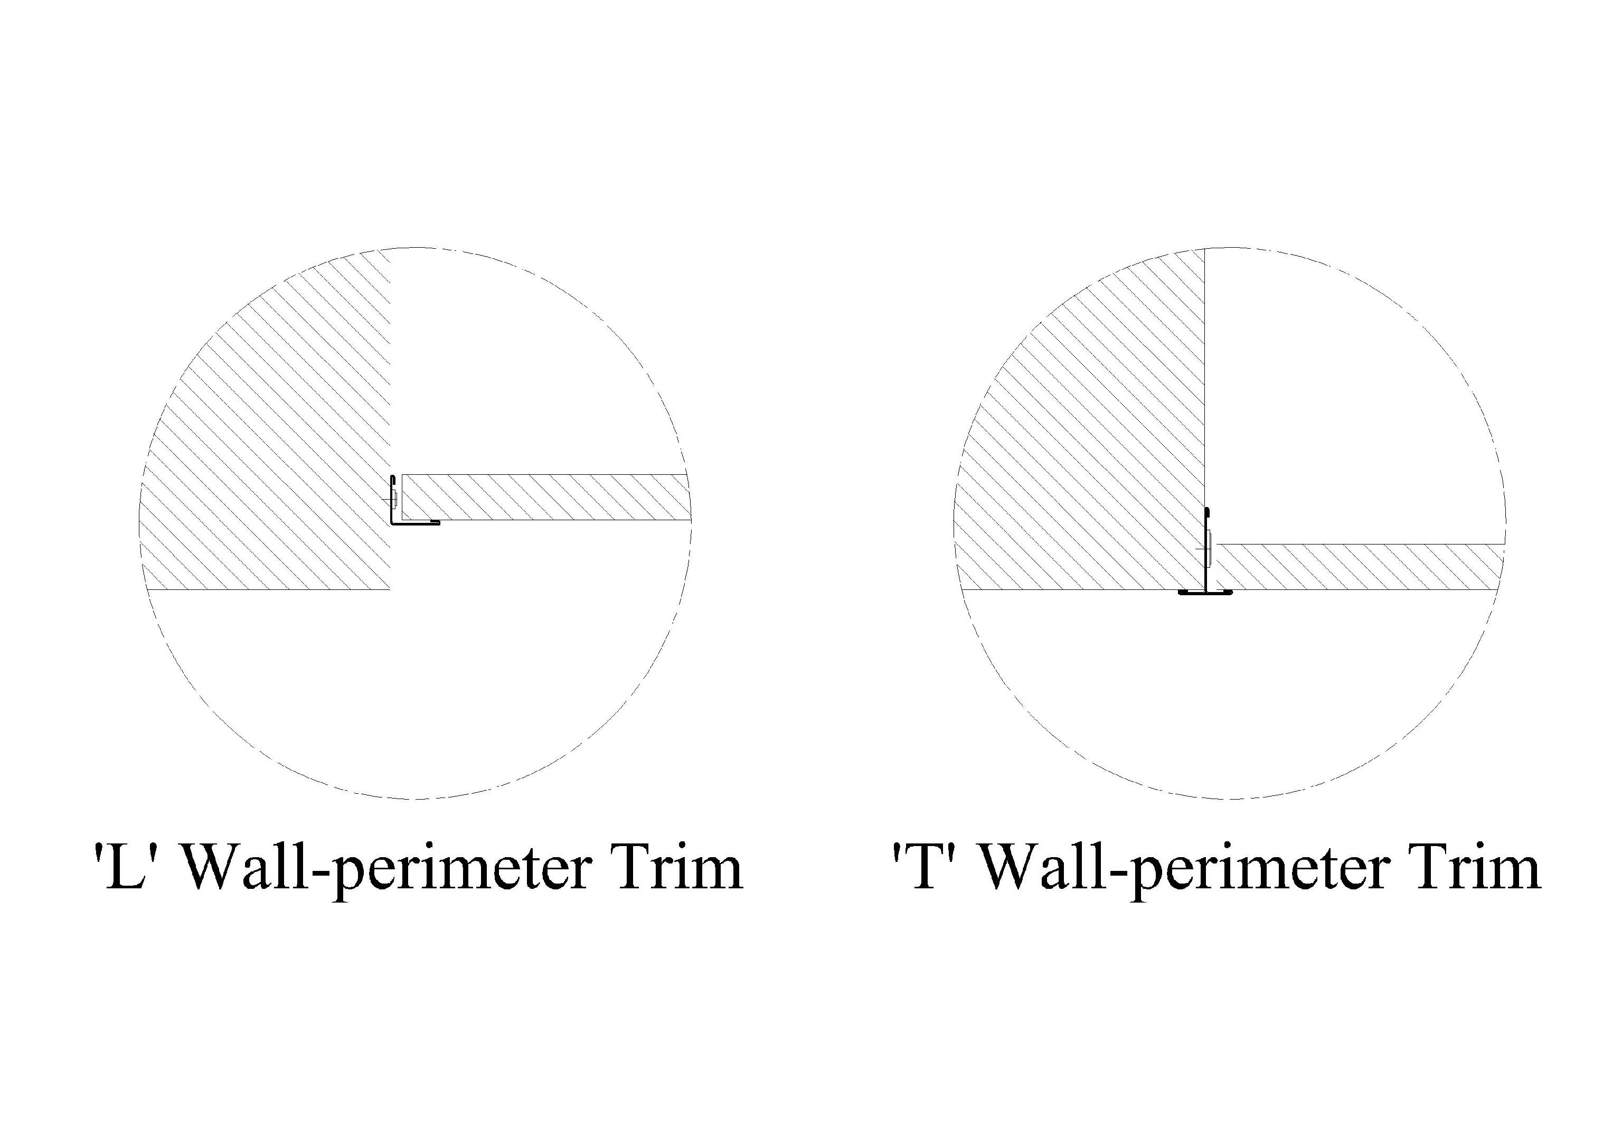
PERFORATIONS 