

DECKON PREMIUM METAL CEILINGS
VECTORIAL CEILING SYSTEM
DATASHEET
Technical Info:
Product : aluminium or galvanised steel
Module : V100 – V200
Thickness : 0.50 - 0.70 mm
Surface : electrostatic powder coated
Perforation : none or ∅1.8-2.5mm hole diameter
Suspension sys : main carrier profile
Fire Resistance : class A as steel
Color : RAL 9016 - standard white or desired RAL colors

Specification:
Baffle and vectorial ceiling systems are made of vertically installed panels in different sizes. A light - weight and floating ceiling system which visually reduces the room height whilst retaining the actual room volume. It is specially designed to hide ser - vices installations such as pipes, lighting and ac/ hvac etc. with a directional approach. Panels are floating on the ceiling with a lineer view and offering a spacious environment. Also baffles with wooden look are available so that the users have more durable and easy maintenance ceiling elements. Different design options can be provided by chang - ing the base sizes of the u profiles, height and the gap between to baffles. Both baffle and vectorial systems enable easy access to the plenum and easy demountability.
VISUAL
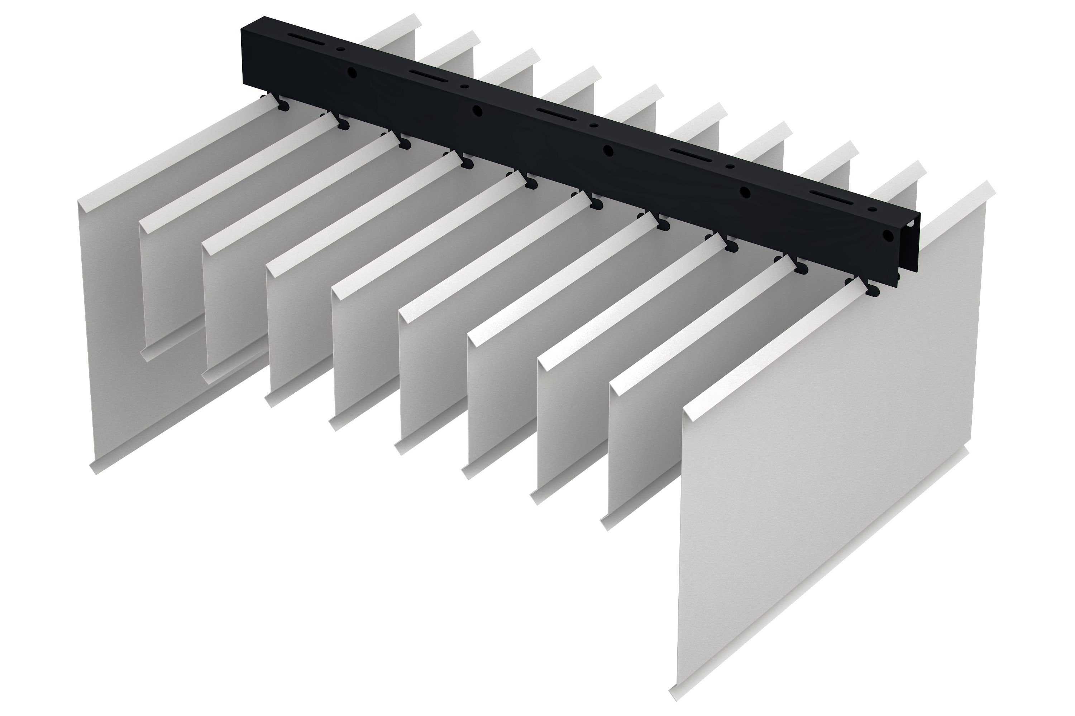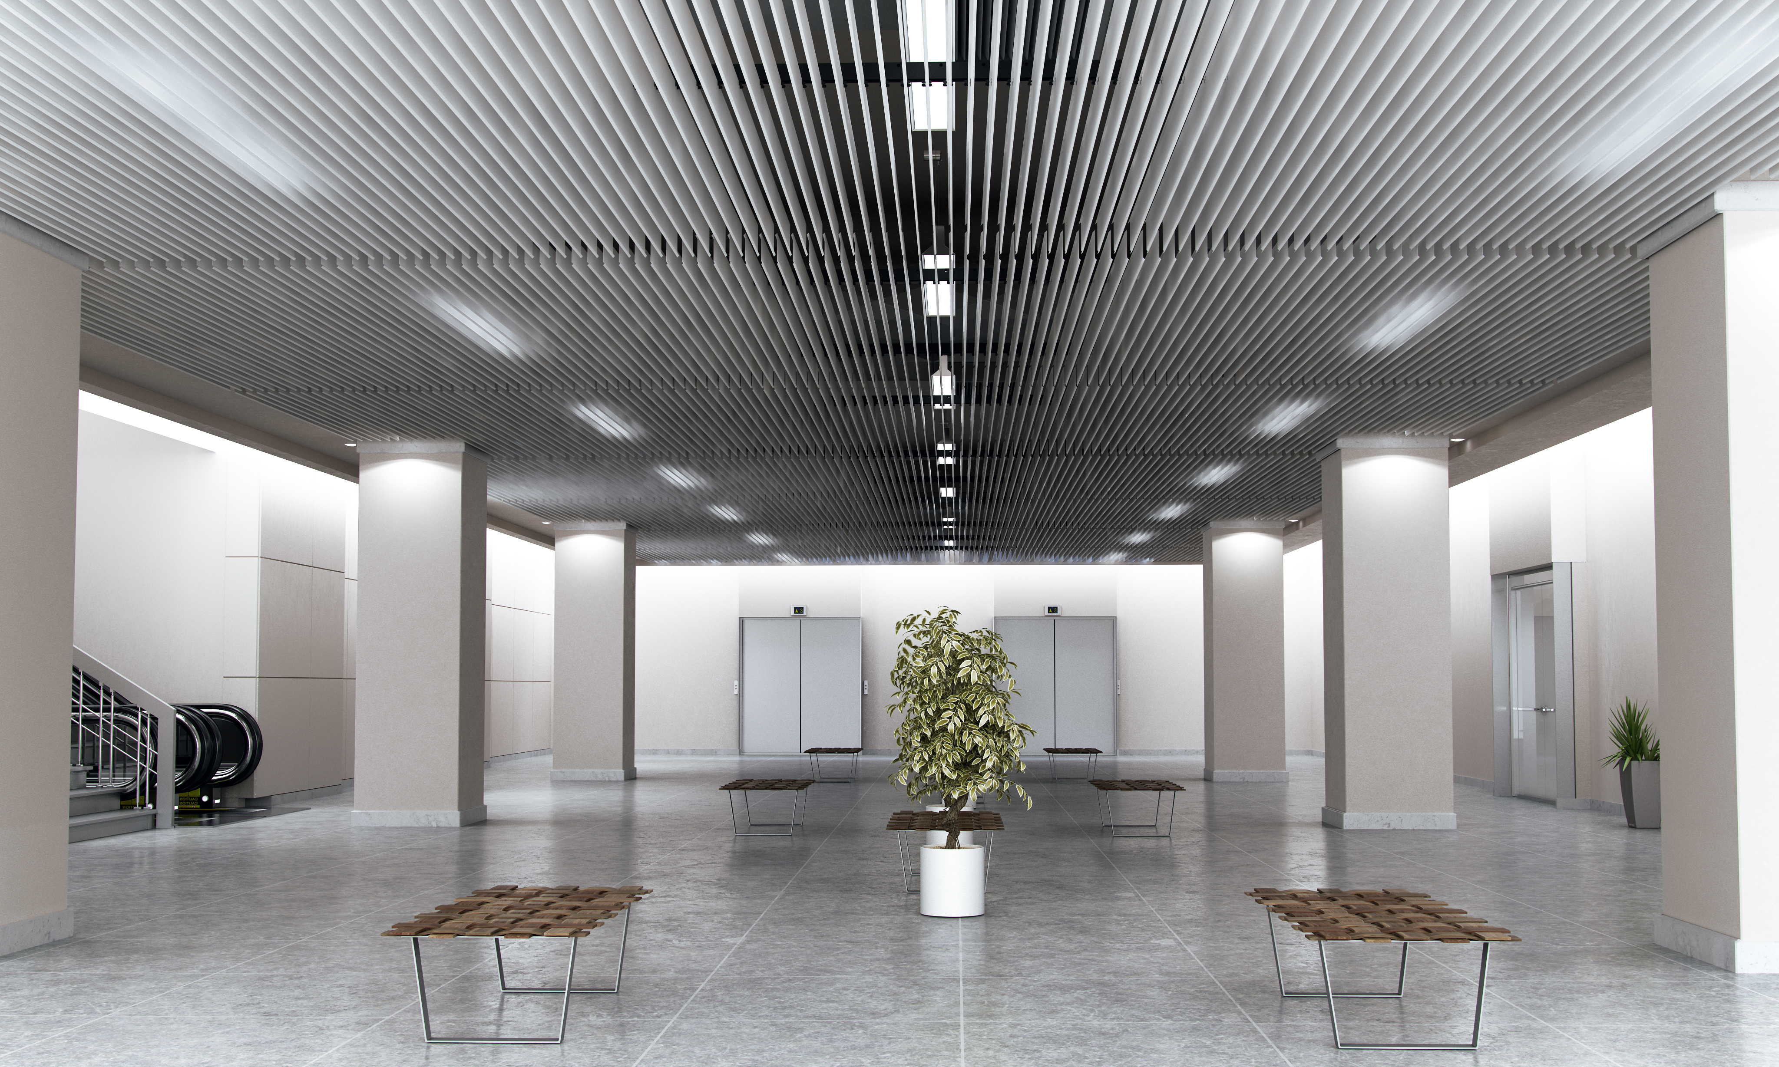
TECHNICAL DRAWING

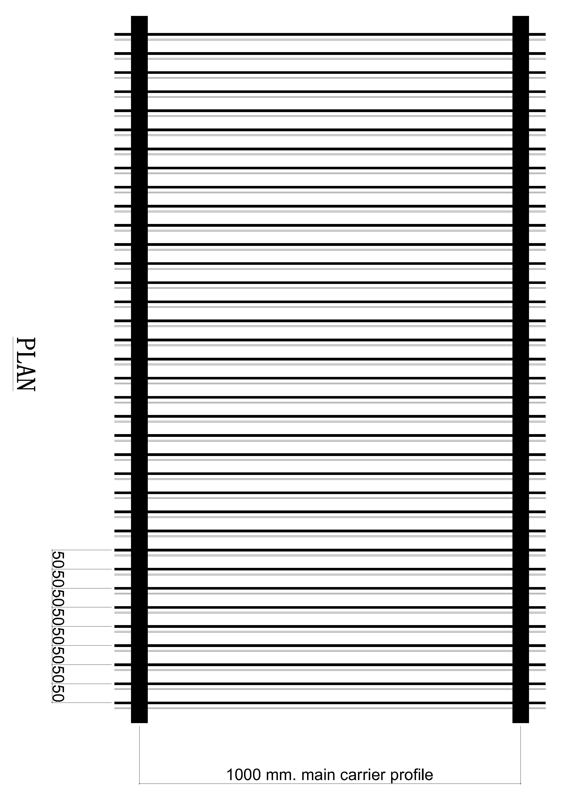

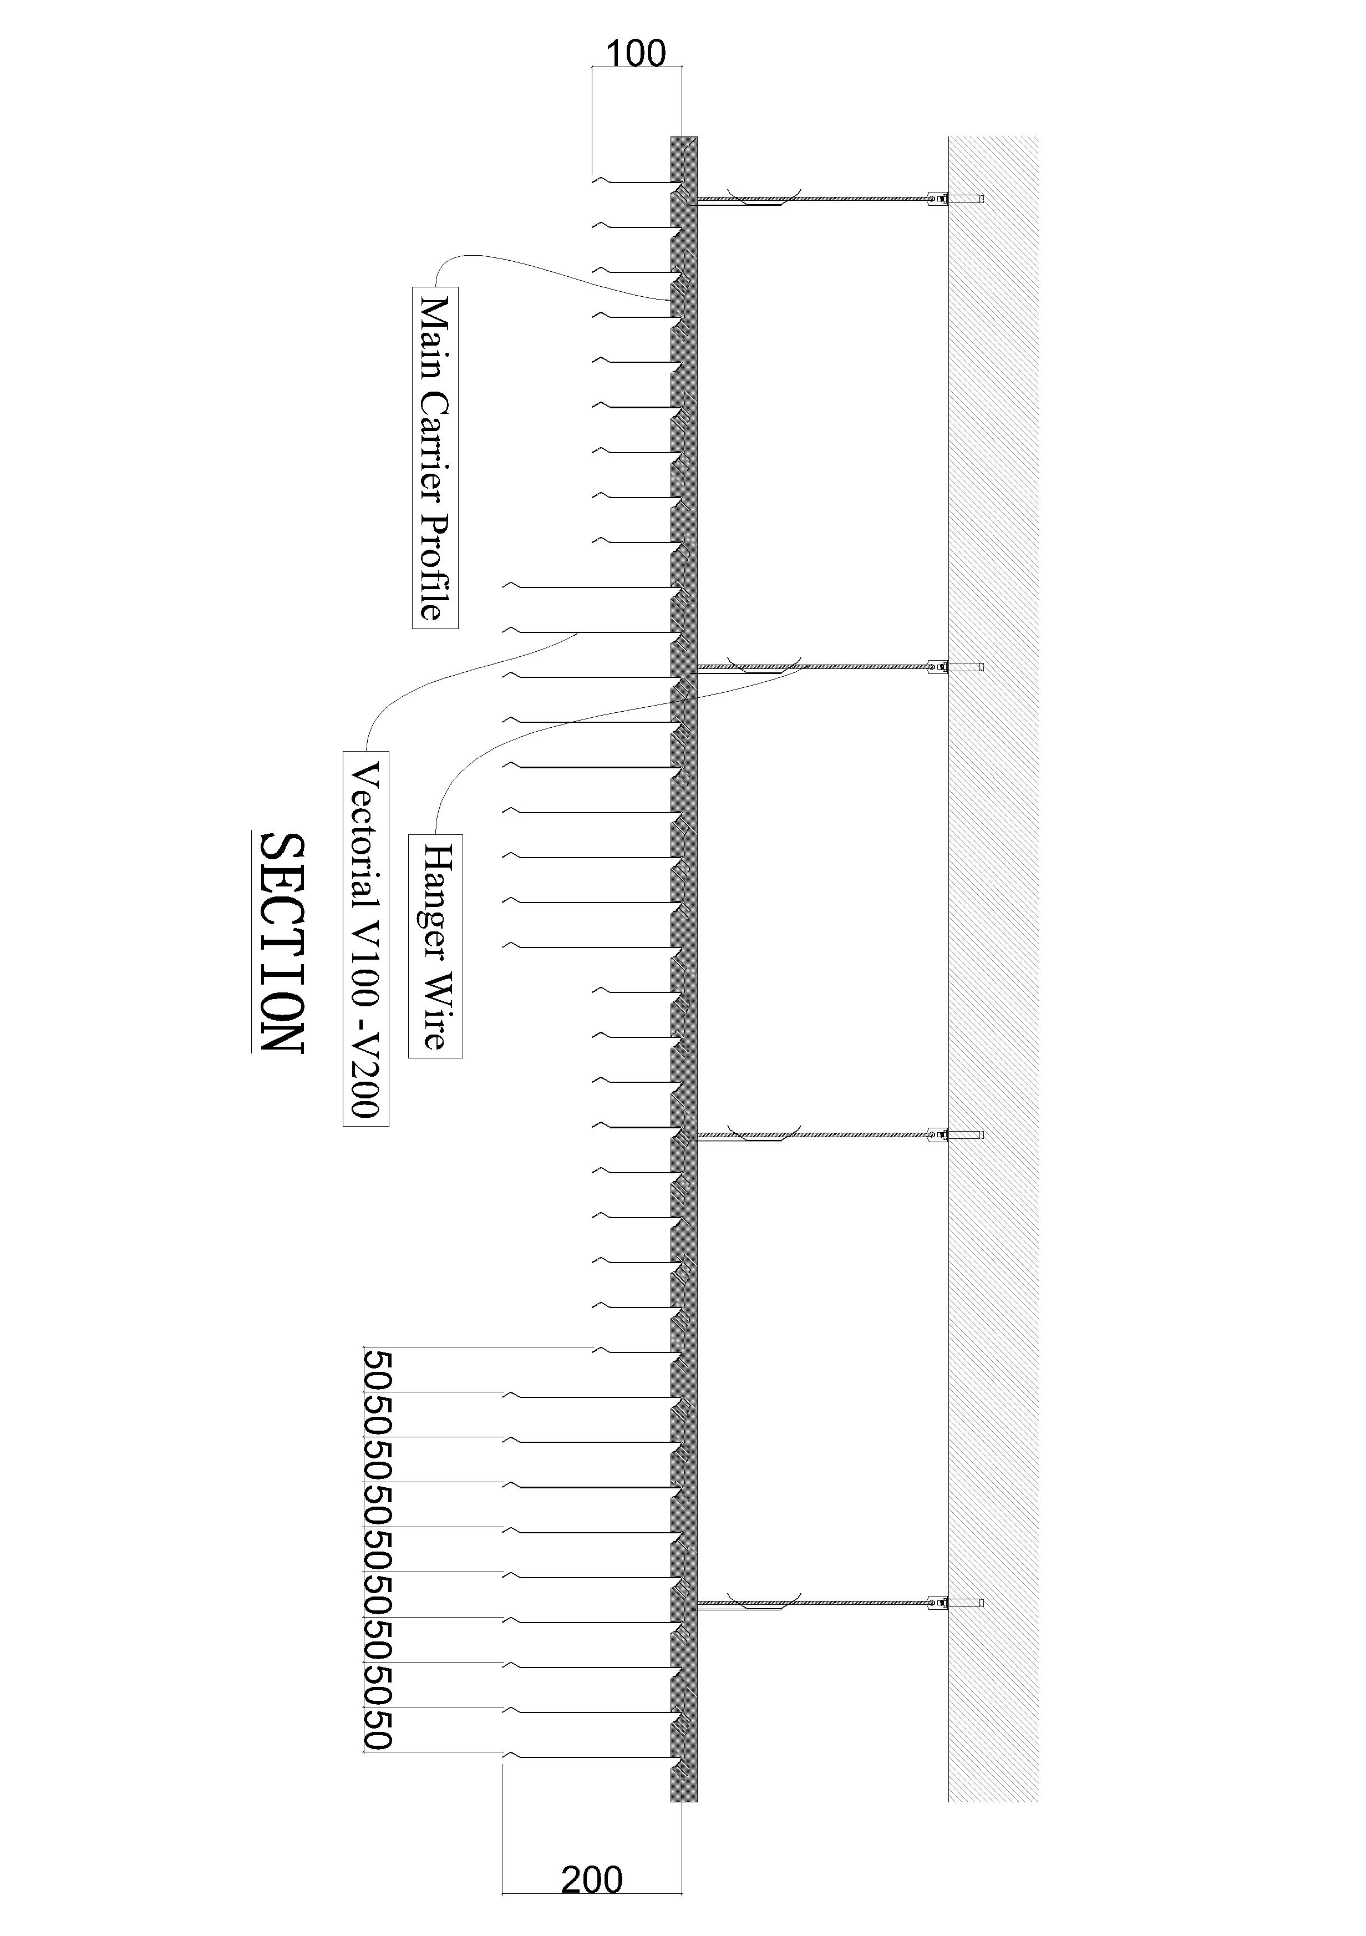
PERFORATIONS 