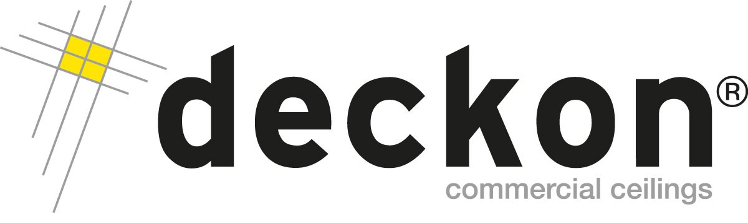

DECKON PREMIUM METAL CEILINGS
HOOK-ON SYSTEM
DATASHEET

Technical Info:

Product : aluminium or galvanised steel
Sizes : 600x600mm, 300x600mm, 600x1200mm std
Thickness : 0.50 - 0.70 mm
Surface : electrostatic powder coated
Perforation : none or ∅1.8-2.5mm hole diameter with 10-50-100mm bordure
Suspension sys : hot dip galvanised steel, black
Edge detail : 20-30mm up-turns, as specified
Fire Resistance : class A as steel
Color : RAL 9016, standard white

Specification:
Hook-on system, also called as “concealed” is formed by allowing ceiling tiles lean on hook-on profiles (Z and L shape). All tiles are demountable manually without any special tool so that the system enables fast and easy access to the ceiling void.
VISUAL
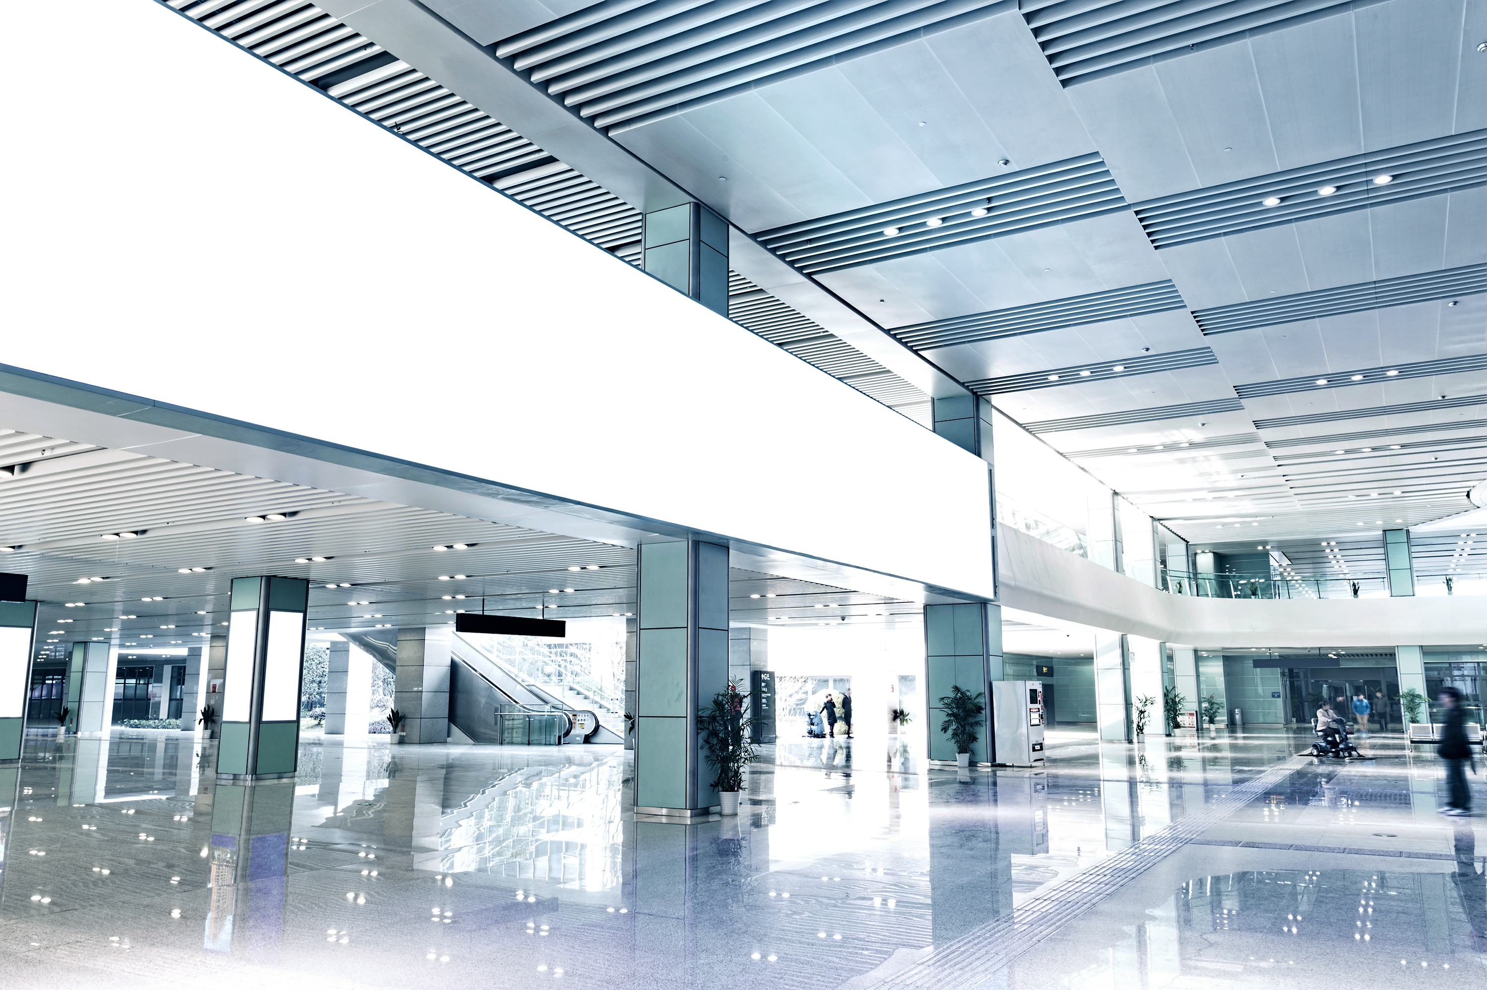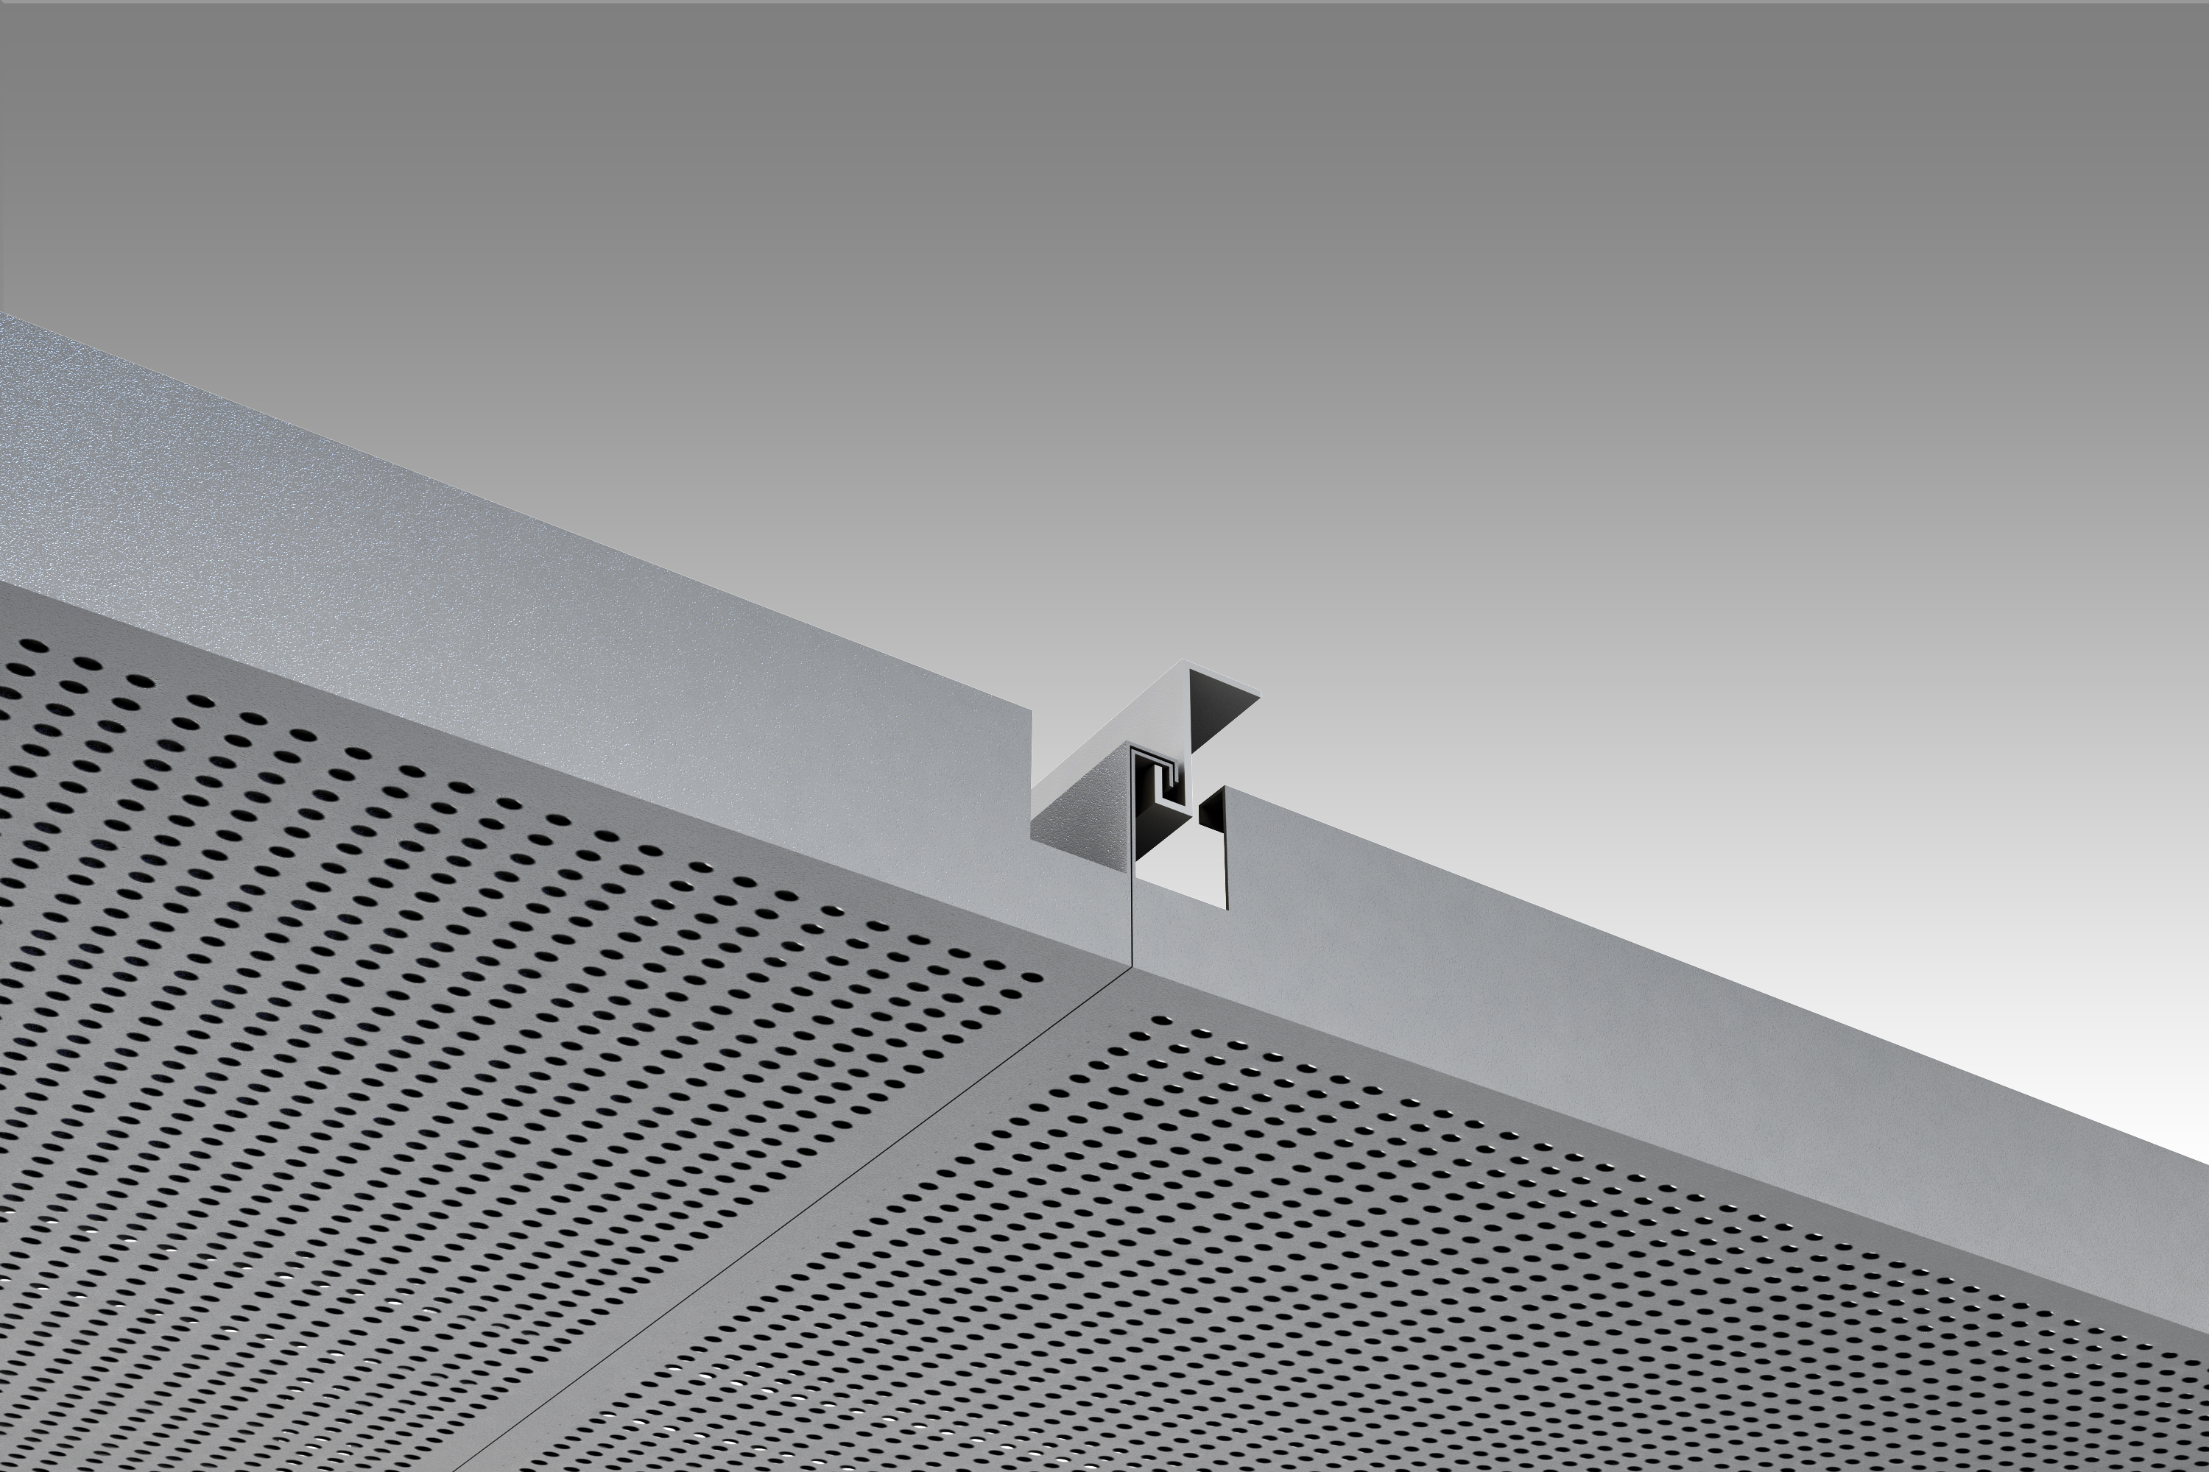

TECHNICAL DRAWINGS
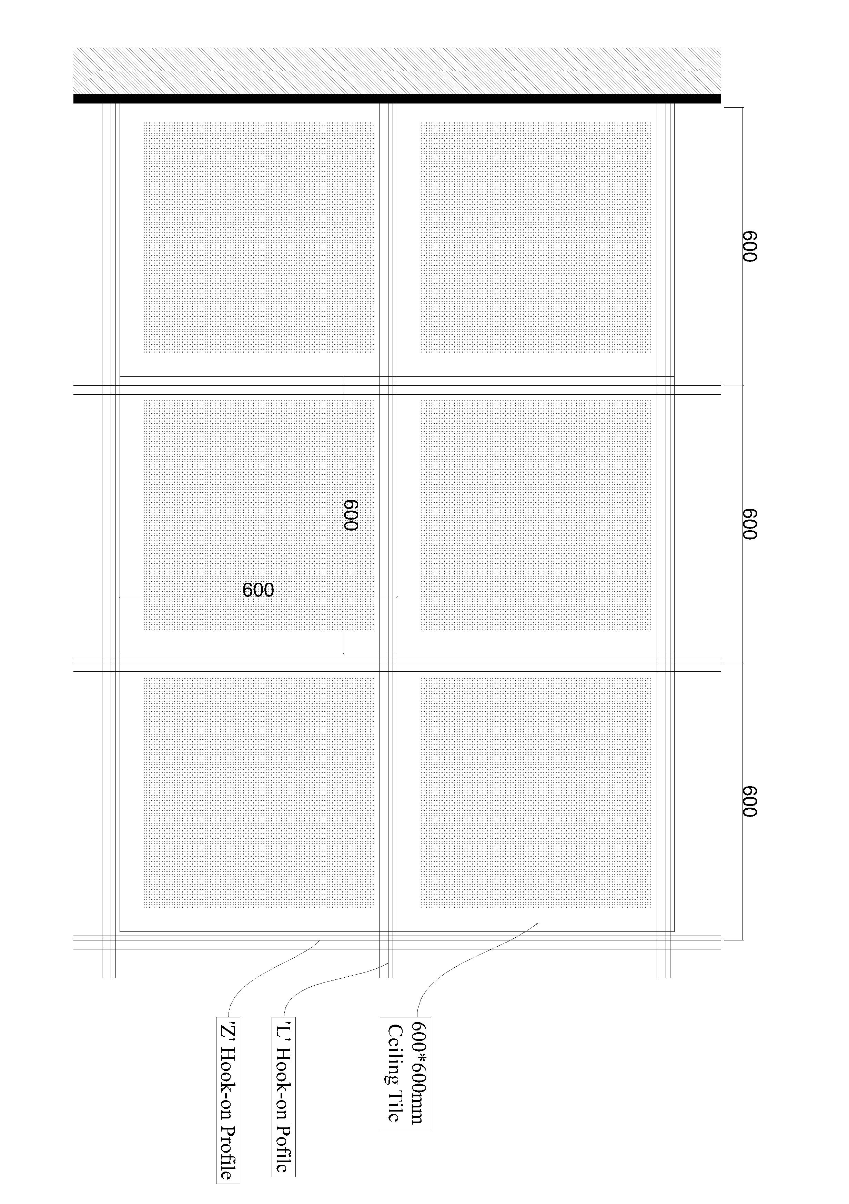
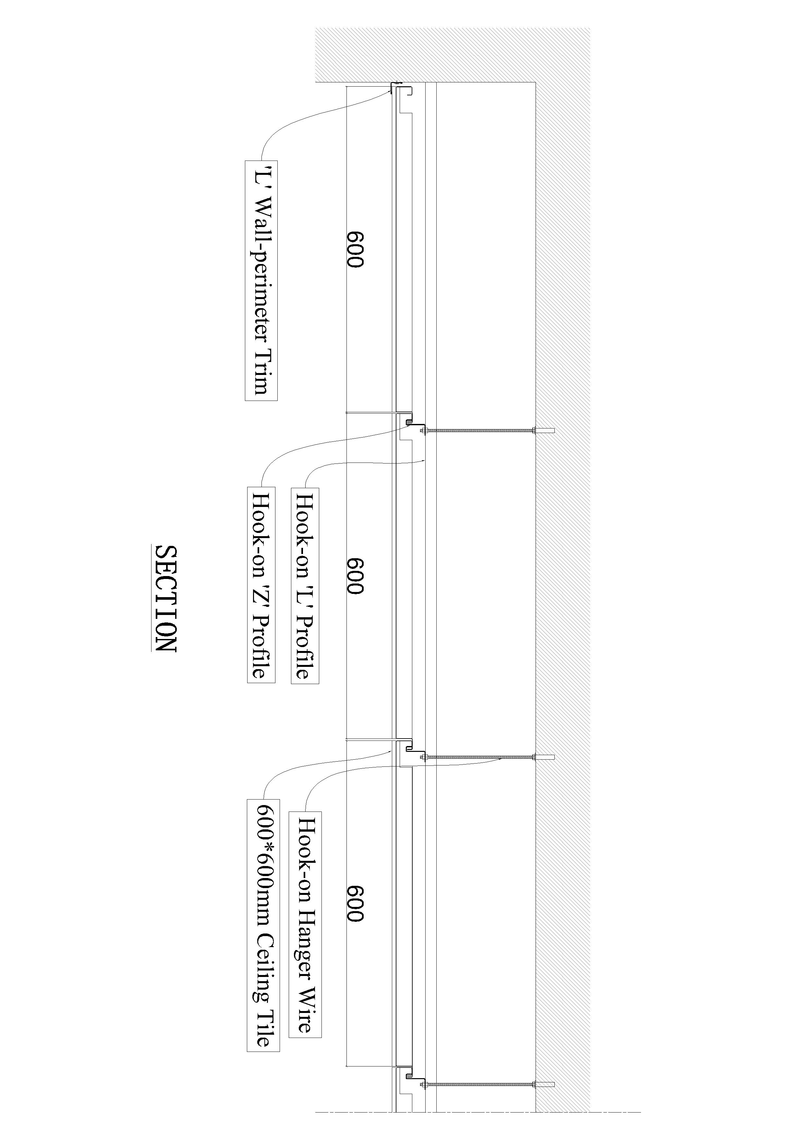
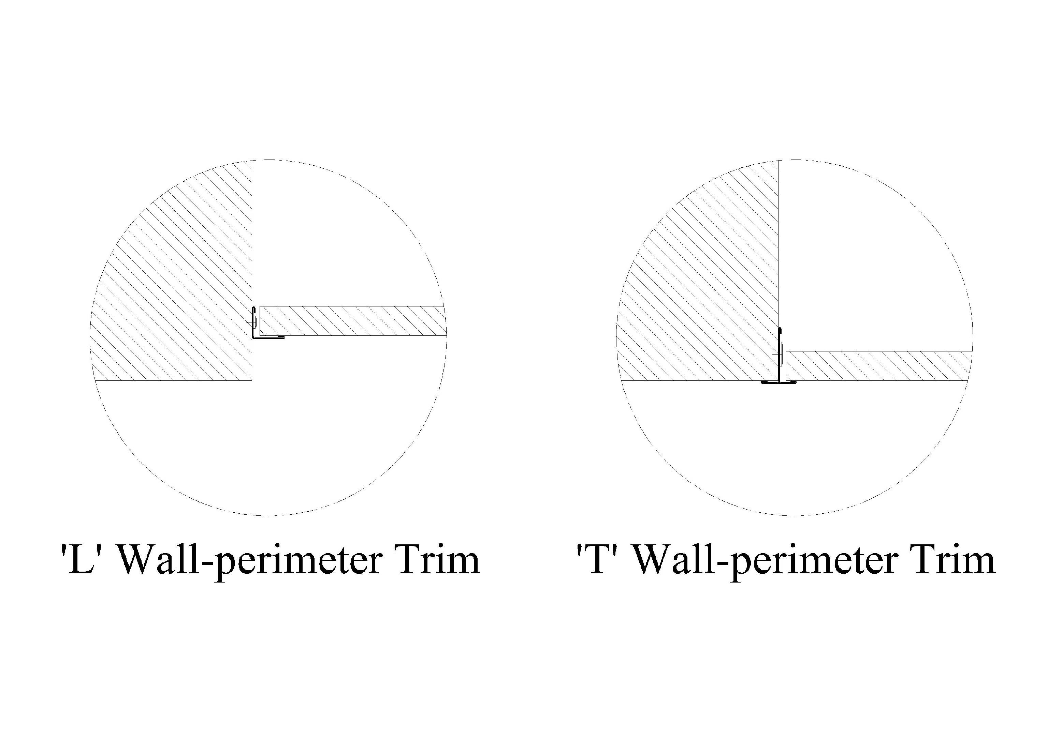
PERFORATIONS
