

WOOD LINEAR SUSPENDED CEILING SYSTEM
DATASHEET

Technical Info:

Product : Wood Linear Suspended Ceiling System
Sizes : 18x100mm, lengths : according to shop drawing
Suspension System : Hook-on system made of main runner Z (20x40x20x1mm), main runner L (25x25x1mm), galvanised steel, with slots and holes
Specification:
c/c: 100mm center to center distance.

Drawing 1: Wood Linear Ceiling Plan
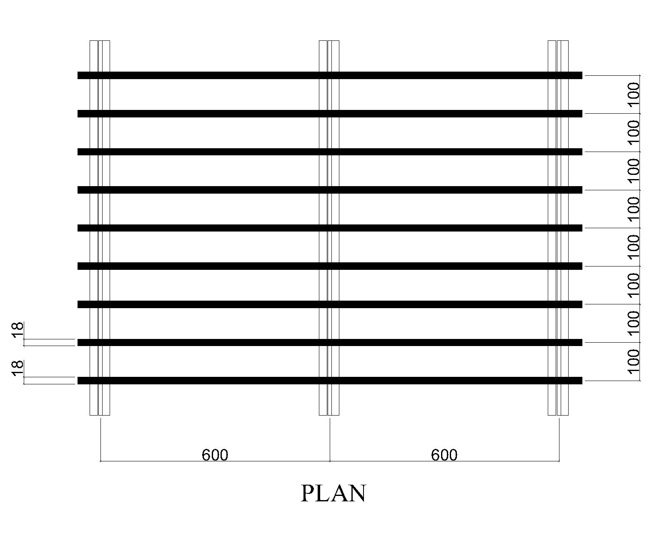

Drawing 2: Wood Linear Ceiling Section
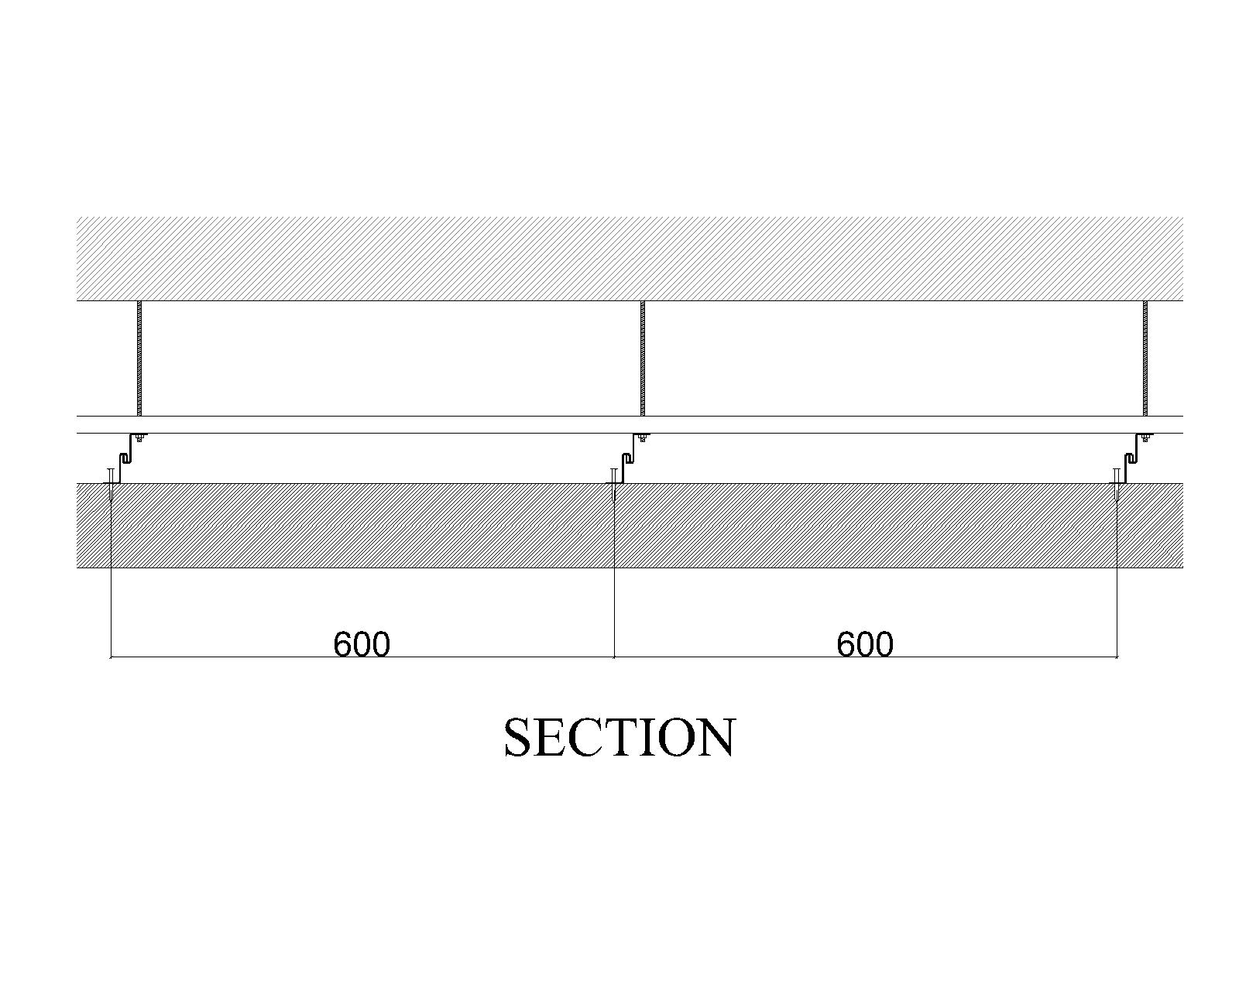
Drawing 3: Wood Linear Ceiling Detail
